**RFID BASED SECURITY AND AUTHENTICATION SYSTEM**

A MINI PROJECT REPORT

*Submitted by*

1. **Atul Jalindar Gaikwad**
2. **Amitkumar G. Shingankar**
3. **Rohan Sunil Kamthe**

TO THE SAVITRIBAI PHULE PUNE UNIVERSITY, PUNE

*In partial fulfillment for the award of the Degree of*

**Bachelor of Engineering**

In

ELECTRONICS ENGINEERING

**Under the Guidance of**

**Prof. N. P. Mawale sir**



**DEPARTMENT OF ELECTRONICS AND TELECOMMUNICATION ENGINEERING**

**All India Shri Shivaji Memorial Society’s**

**College of Engineering, Pune-1**

**APRIL- 2018.**



CERTIFICATE

This is to certify that the Mini Project Report entitled:

RFID BASED SECURITY AND AUTHENTICATION SYSTEM Submitted by: Mr. Atul J. Gaikwad Seat No. T150213818

Mr. Amitkumar G. Shingankar Seat No. T150213867

Mr. Rohan S. Kamthe Seat No. T150213832

is a bonafide record of the work carried out by him/her towards the partial fulfillment of the requirements of Savitribai Phule Pune University, for the award of degree of Bachelor of Engineering in Electronics Engineering under my/our supervision and guidance.

Signature of the Guide

Name of the Guide: N. P. Mawale

Designation:

|  |  |
| --- | --- |
| Dr. D. S. Bormane | Dr. D. S. Bormane |
| **HOD** | **Principal** |
| **Electronics & TC Engineering** | **AISSMS COE, Pune-41** |

Date:

Place:

**________________________________________________________________________**

This report has been examined by us as per the SAVITRIBAI PHULE PUNE UNIVERSITY, PUNE, requirements at **AISSMS** **COE Pune-1 on Date: _______________**

|  |  |  |
| --- | --- | --- |
| Signature |  | Signature |
| Name: |  | Name: |
| **Internal Examiner** |  | **External Examiner** |

**CONTENTS**

Acknowledgement ………………………………….……………………………I

Declaration………………………………………….……………..….…….……II

Table of Contents………………………………….…………………………….III

Abstract ………………………………………………………………………....IV

List of Figures …………………………………………………………………...V

List of Tables …………………………………………………………………...VI

List of Acronyms …………………………………………………..….……….VII

**Chapter No. Title of Chapter Page No.**

1. **Introduction**
   1. Introduction ……………………………………..12

1.2 Motivation ………………………………………12

* 1. Problem Statement ……………………………...12

1. **Block diagram** 
   1. Blockdiagram…………………………………
2. **Circuit diagram and description**
   1. Circuit diagram ……………………………….
3. **Literature Survey and Selection of Component**
   1. PIC18F4520……………………………………
   2. LCD Display …………………………………..
   3. LED …………………………………………..
   4. L293D motor driver…………………………
   5. RFID module …………………………………
   6. Power Supply …………..
      1. Transformer …………………………
      2. Regulator 7805 & 7812………………
      3. 1N4007 rectifier diode ……………
      4. Capacitor ……………..
   7. Register………………………………………...
   8. DB-9…………………………………………..
   9. POT ……………………………………..
   10. RFID Tag……………………………………..
4. **Component Pricing.......................................................**
5. **Software and Features**
   1. Proteus …………………………………………
   2. Pad2Pad……………………………………….
   3. MP lab …………………………………………
6. **Program Analysis and Simulation**
   1. Software Design Aspects.......................................
      1. Algorithm..................................................
      2. Flow Chart.................................................

7.1.3 Program……….………………………….

* 1. Simulation Result……………………………….
  2. PCB Layout
  3. Art work.................................................................
     1. Materials…………………………………
     2. Patterning………………………………..
     3. Etching………………………………….
     4. Drilling………………………………….
     5. Damage………………………………….
     6. Exposed Conducting and Coating…..…..
     7. Solder Resist …………………………….
     8. Component Mounting …………………….
     9. Soldering …………………………………..
     10. Precautions ……………………………….

1. **Conclusion and Future Scope**
   1. Results ………………………………………………
   2. Advantages ……………………………………….
   3. Limitations ………………………………………
   4. Conclusion ……………………………………….
   5. Application ……………………………………….
   6. Future Scope ……………………………….……
2. **Reference ……………………………………………**

**Acknowledgement**

The satisfaction that accompanies the successful completion of this project would be incomplete without the mention of the people who made it possible, without whose constant guidance and encouragement would have made efforts go in vain. We consider myself privileged to express gratitude and respect towards all those who guided us through the completion of this project.

We convey thanks to my project guide Prof. N. P. Mawale for providing encouragement, constant support and guidance which was of a great help to complete this project successfully. He helped us in, how to do things easily and how to manage it which helps more while actual working on project. We have improved our presentation skills by their comments and tips.

We would also like to thank the role of the staff of Electronics Laboratory, they helped us in necessary material to complete the simulation and understanding the concepts more elaborately.

Last but not the least, we wish to thank our parents for financing our studies in this college as well as for constantly encouraging us to learn engineering. Their personal sacrifice in providing this opportunity to learn engineering is gratefully acknowledged.

Thank you.

**DECLARATION**

We hereby declare that this submission is our work and that, to the best of our knowledge and belief, it contains no material previously published or written by another person nor material which has been accepted for award of any other degree or diploma of the university or other institute of higher learning, except where due acknowledgement has been made in the text.

**Place:**

**Date:**

**Signature of Student**

**Name: Atul Jalindar Gaikwad**

**PRN: 71532879E**

**Signature of Student**

**Name: Amitkumar G. Shingankar**

**PRN: 71533287C**

**Signature of Student**

**Name: Rohan Sunil Kamthe**

**PRN: 71532973B**

**ABSTRACT**

Now a days all the data of companies, colleges or any organizations is stored in digital format. So the safety of this precious data is the major concern of any authorities.

In this project, the low cost RFID Based Security and Authentication System has been designed with using PIC 18F4520. It checks the authorized or unauthorized person and displayed on LCD.

The concern is for the physical property and also for the intellectual property. So it is important to secure it from unauthorized or unwanted person.

For this reason, by installing this system in organization, only the authorized person with a valid RFID tag is allowed into the secured premises.

In such a way, unauthorized persons can be caught which will surely improve the security level in the organization.

`

**List of figures**

|  |  |  |
| --- | --- | --- |
| **Figure no.** | **Name of figure** | **Page No.** |
| Figure no.2.1.1 | Block diagram of main design | 14 |
| Figure no.3.1(a) | Circuit Diagram on paper | 16 |
| Figure no.3.1(b) | Circuit Diagram on Proteus | 17 |
| Figure no.4.1.1 | Pin diagram of PIC18F4520 | 20 |
| Figure no.4.2.1 | 16x2 LCD | 20 |
| Figure no.4.3.1 | LED | 21 |
| Figure no.4.4.1 | Pin diagram of L293D | 22 |
| Figure no.4.5.1 | RFID Module | 24 |
| Figure no.4.6.1 | Transformer | 25 |
| Figure no.4.6.2 | 1N4007 Diode | 25 |
| Figure no.4.6.3 | Voltage Regulator | 26 |
| Figure no.4.6.4 | Capacitor | 26 |
| Figure no.4.7.1 | Resistor | 27 |
| Figure no.4.8.1 | DB-9 | 27 |
| Figure no.4.9.1 | POT | 28 |
| Figure no.3.2(b) | DC Motor | 15 |
| Figure no.5.1 | Simulation result | 19 |
| Figure no.5.3 | PCB layout | 27 |
| Figure no.5.4.3 | Etching | 29 |
| Figure no.5.4.9 | Components mounting | 32 |
| Figure no.5.4.10 | Soldering | 33 |
| Figure no.6.1 | Result | 35 |

**List of tables**

|  |  |  |
| --- | --- | --- |
| **Table no.** | **Name of table** | **Page no.** |
| Table no. 4.4(a) | L293D | 23 |
| Table no.4.7.1 | Resistor | 27 |
| Table no.4.2 | Component pricing | 19 |

**CHAPTER 1**

**INTRODUCTION**

**1.1 INTRODUCTION**

Every companies or in big offices administrators are concerned about their data security. The conventional method allowing access to authorized person inside an office or a sensitive area is by showing i-cards to security guard is very time consuming and insecure, hence inefficient. Radio Frequency Identification (RFID) based security system is one of the solutions to address this problem. This system can be used to allow access for authorized person in sensitive area / premises. It also can be used at the entrance for workers in working places. Its ability to uniquely identify each person based on their RFID tag type of ID card make the process of allowing security access easier, faster and secure as compared to conventional method. Students or workers only need to place their ID card on the reader and they will be allowed to enter the campus for workers, or the authorized person the restricted area or sensitive area. And if any invalid card is shown then the RED LED is turned on.

**1.2 MOTIVATION**

This year our college started a new club of Robotics and Drones, so many high quality material used for drone and robotics are available there. Many students visited our club for curiosity of new things happening there. The possibility of mishandling of the component increased so we decided to allow our team member to the specified area of the club. From this we got an idea to make a project on the basis of access control of sensitive area using RFID module. In this way, we are come to conclusion to make project on RFID based security system for any organization.

**1.3 PROBLEM STATEMENTS**

The RFID based security system is being developed for the following reasons:

* Providing better security for the premises or sensitive area automatically with reducing human efforts.
* To protect the important data or instruments of a company or any big business organization form mishandling issues.

**CHAPTER 2**

**BLOCK DIAGRAM AND DESCRIPTION**

**2.1 BLOCK DIAGRAM**

**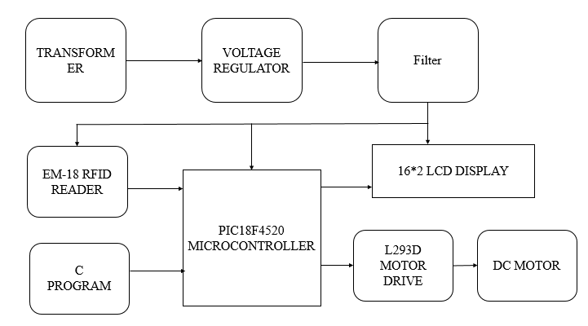****Fig. no. 2.1.1:** Block Diagram

**2.1.1 BLOCK DIAGRAM DESCRIPTION**

Voltage regulators produce fixed DC output voltage from variable DC. In microcontroller, a fixed frequency has to give. Here we are using a 12V and 5V power supply for operation of the project. Two 1000uf capacitors are used for the filter purpose. A 230V AC to 12V DC transformer of 1A current rating is used here. We are using 1N4007 rectifier diode, they usually slow to measure the drop across the diode connect a load resistance across the cathode terminal and other terminal of the load is connected to negative terminal of the battery. At finally 12V and 5V constant supply is generated, in which 12V power supply is required for operation of DC motor and other component like LCD, Microcontroller, L293D motor driver IC, LED RFID module all are running on 5V power supply. Here we using PIC18F45520 microcontroller for all working of the project, input is taken from RFID reader, here EM-18 is the RFID reader which given input to the microcontroller and after checking the data available on server it gives commands to the L293D motor driver IC which drives the DC motor which shows the operation of the door.

**CHAPTER 3**

**CIRCUIT DIAGRAM AND WORKING**

**3.1 CIRCUIT DIAGRAM and WORKING**

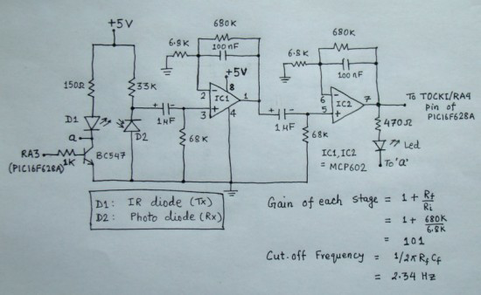

**Fig.3.1 (a)** Circuit Diagram

* **Working:**

First of all RFID module reads and retrieve the data from the RFID tag

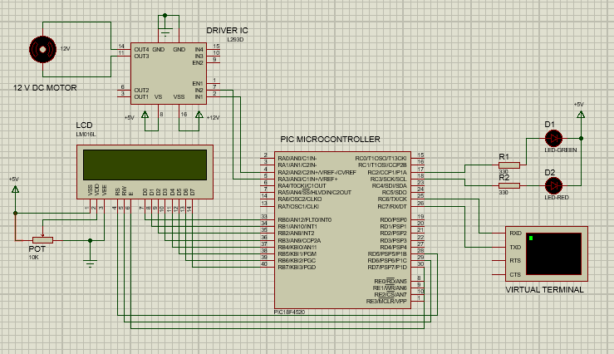

**Fig. no 3.1 (b)** Circuit Diagram

**CHAPTER 4**

**LITERATURE SURVEY AND SELECTION OF COMPONENTS**

**HARDWARE AND FEATURES**

* µC: PIC18F4520
* 16x2 LCD Display, 100 mA, Alphanumeric Display
* L293D
* LED
* RFID module
* Power Supply
* DC MOTOR
* DB-9
* RFID tags

**4.1 PIC18F4520 µC**

A microcontroller (sometimes abbreviated μC or MCU) is a small computer on a single integrated circuit containing a processor core, memory, and programmable input/output peripherals. It is a simplified CPU, plus some amount of RAM, plus some amount of (re)programmable ROM, plus some I/O ports (including some analog I/O ports), and all of this in a single small chip.

Microcontrollers are used in automatically controlled products and devices, such as automobile engine control systems, implantable medical devices, remote controls, office machines, appliances, power tools, and toys. These are also used at many electronic devices, including microwave ovens and washing machines. They are simple and useful enough to be used in many DIY (do it yourself) projects. They usually can run at a clock rate of a few MHz

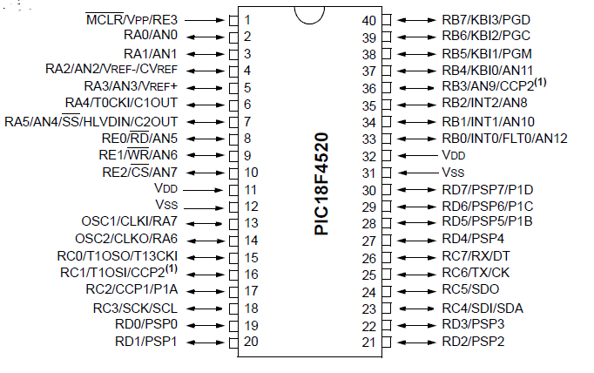

**Fig. no.** **4.1.1** Pin Diagram of PIC18F4520

**4.2 LIQUID CRYSTAL DISPLAY**

LCD is used in a project to visualize the output of the application. We have used 16×2 LCD which indicates 16 columns and 2 rows. So, we can write 16 characters in each line. So, total 32 characters can be displayed on this LCD.

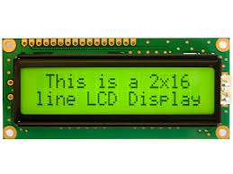

**Fig.4.2.1** 16x2 LCD

In this very project, the LCD is used to display the count of people in the lift. It also displays an error message on violation of the allowed number of people. Thus the LCD plays a vital role in a project to see the output and to debug the system module wise in case of system failure in order to rectify the problem.

**4.3 LED**

In this project we are using LED as output device. When person shows the authorized RFID card then is blink green LED and if unauthorized card shown it blinks the red for some time, after some delay the LED will off.

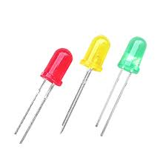

**Fig. no.4.3.1:** LED

**4.4 L293D**

L293D is a typical Motor driver or Motor Driver IC which allows DC motor to drive on either direction. L293D is a 16-pin IC which can control a set of two DC motors simultaneously in any direction. It means that you can control two DC motor with a single L293D IC.

It works on the concept of H-bridge. H-bridge is a circuit which allows the voltage to be flown in either direction. As you know voltage need to change its direction for being able to rotate the motor in clockwise or anticlockwise direction, hence H-bridge IC are ideal for driving a DC motor.

**Features:**  
 The L293D is a popular motor driver IC that is usable from 5 to12V, at up to 1A total output current. By itself, the IC is somewhat difficult to wire and use, but the Compact L293D Motor Driver makes it much more convenient to use.

* Schottky EMF-protection diodes
* Socket pin connectors for easy logic interfacing
* Enable pins are user accessible.

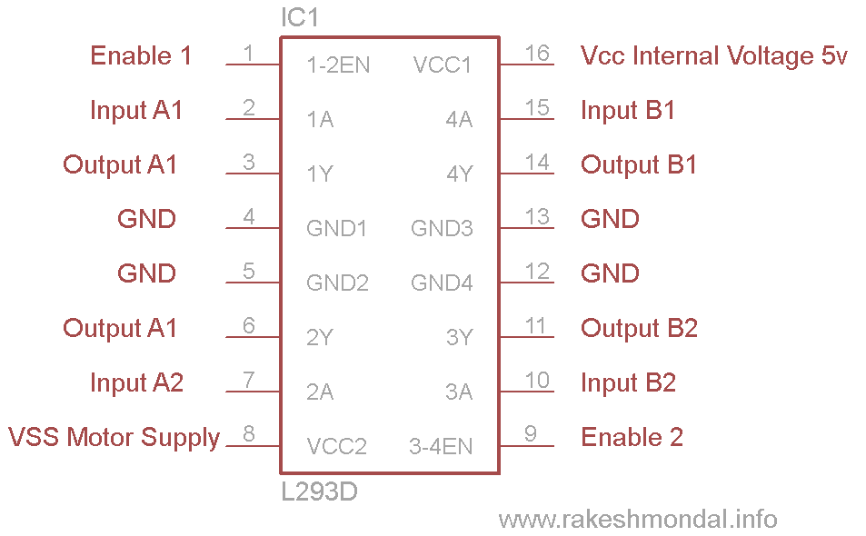

**Fig no. 4.4.1** Pin Diagram of L298D

## L293D Logic Table.

## Let’s consider a Motor connected on left side output pins (11, 14). For rotating the motor in clockwise direction the input pins has to be provided with Logic 1 and Logic 0.

|  |  |  |
| --- | --- | --- |
| **Pin 15** | **Pin 10** | Description |
| **Logic 1** | **Logic 0** | Clockwise Direction |
| **Logic 0** | **Logic 1** | Anticlockwise Direction |
| **Logic 0** | **Logic 0** | Idle [No rotation] [Hi-Impedance state] |
| **Logic 1** | **Logic 1** | Idle [No rotation] |

## Table no. 4.4(a): L293D Logic Table.

* **4.5 EM-18 RFID Module:**

This module directly connects to any microcontroller UART or through a DB9 converter to PC. It gives UART/Wiegand26 output. This RFID Reader Module works with any 125 KHz RFID tags.***Specifications*:**

* 5VDC through USB (External 5V supply will boost range of the module)
* Current: <50mA
* Operating Frequency: 125Khz
* Read Distance: 10cm
* Size of RFID reader module: 32mm(length) * 32mm(width) * 8mm(height)

### http://www.nskelectronics.com/imagebrowser/ib_p311_1_1.jpg

### Fig no.4.5.1: RFID Module

### DB-9 Female connector

### Buzzer

### 7805 voltage regulator

### Capacitor of 220 and 470 micro farad

### Switches

### RED and GREEN LED

**4.6 POWER SUPPLY**

For our project we require +5volt and +12 Volts supply. +5volt is to LCD display, LED, and MICROCONTROLLER. And 12 volts supply used for operation of DC motor.

**4.6.1 TRANSFORMER**

A Transformer is a static apparatus, with no moving parts, which transforms electrical power from one circuit to another with changes in voltage and current and no change in frequency. A Step down Transformer is a type of transformer, which converts a high voltage at the primary side to a low voltage at the secondary side.

The power in a transformer is rated in Volt – Amps VA (or Kilo Volt – Amps kVA for larger transformers).

In our project we are using 230V to 12V step down transformer, current rating of our transformer is 1 amp.

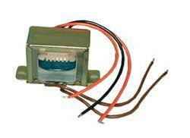

**Fig. no. 4.6.1:** Step down transformer

**4.6.2 1N4007 DIODE**

**Why we use 1N4007 Diodes?**

1N400X diodes are used as rectifiers for low frequency having big capacitance at the junction, other diodes have less capacitance value therefore they have quick ON –OFF time. These 1N4007 diodes are usually slow. To measure the voltage drop across the diode connect a load resistance across the cathode terminal and other terminal of the load is connected to negative terminal of the battery. Then the drop across the diode is 0.7 volts.

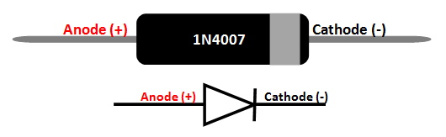

**Fig. no.4.6.2:** 1N4007 Diode

**4.6.3 Voltage Regulator:**

The purpose of regulator is to maintain constant voltage. For positive voltage output use LM78XX, XX indicates value of output voltage and 78 indicates positive output. For negative voltage output use LM79XX, 79 indicate negative voltage and XX indicates value of output. To get positive 5V regulated output use LM7805.To get negative 5V regulated output use LM7905. To get positive 12V regulated output use LM7812

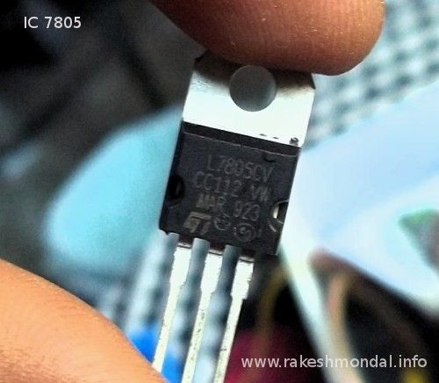

**Fig. no.4.6.3:** Voltage Regulator

**4.6.4 CAPACITORS**

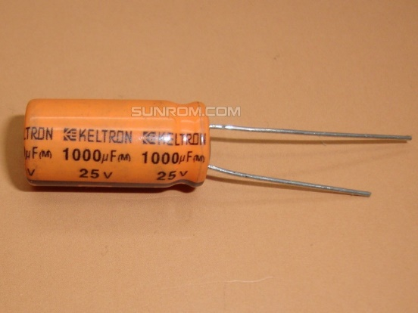 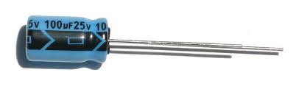

**Fig.no.4.6.4:** Capacitor

Here we use different capacitors ranging are 1000 micro farad, 100 micro farad for filtering and smoothing purpose power supply.

### 4.7 RESISTORS

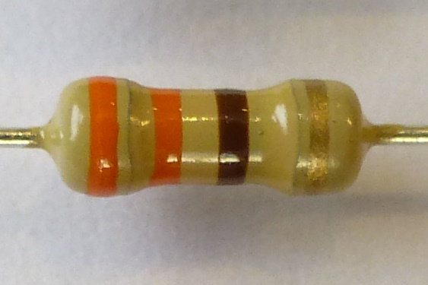

**Fig.no.4.7.1 Resistors**

Here we use number of resistors such as two 330 ohm resistors.

**Specifications of resistor:**

|  |  |
| --- | --- |
| **PARAMETER** | **VALUES** |
| Resistance (Ohms) | 330 |
| Power (Watts) | 0.25W, 1/2W |
| Composition | Carbon Film |
| Features | - |
| Temperature Coefficient | 450ppm/°C |
| Tolerance | ±10% |
| Package / Case | Axial |
| Supplier Device Package | Axial |
| Size / Dimension | 0.094" Dia x 0.248" L (2.40mm x 6.30mm) |
| Height | - |
| Number of Terminations | 2 |

**Table no. 4.7.1:** Specification of resistors

### 4.8 DB-9

### A DB9 connector has 9 pins arranged in two rows as shown in figure having 5 pins in top row and remaining in the bottom.

### DB9 Connector

### Fig. no. 4.8.1: DB-9 connector

### Electric Specifications:

### 1. Operation voltage: 250 VAC max 2. Current rating: 3 Amps max 3. Contact resistance: 20 m Ohms max 4. Insulation resistance: 3000 M Ohms min at 1000 VDC between 5. Dielectric withstanding voltage: 1000 VAC min rms (sea level)

|  |  |  |  |
| --- | --- | --- | --- |
| Pin number | Name | Abbreviation | Direction |
| 1 | Carrier Detect(Received line signal detector) | CD | In |
| 2 | Receive Data | RXD/RX/RD | In |
| 3 | Transmit Data | TXD/TX/TD | Out |
| 4 | Data Terminal Ready | DTR | Out |
| 5 | Signal Ground | GND | - |
| 6 | Data Set Ready | DSR | In |
| 7 | Request To Send | RTS | Out |
| 8 | Clear To Send | CTS | In |
| 9 | Ring Indicator | RI | In |

### Table no. 4.8: DB-9 connector

### 4.9 POT

### **Potentiometer** is a small sized electronic component whose resistance can be adjusted manually. Increasing or decreasing the value of resistance controls the amount of current flowing in a circuit. Using this potentiometer we are controlling the contrast of the LCD screen.

### Image result for 10k potentiometer

### Fig, no.4.9.1: POT

### 4.10 RFID tags

### It contains information of user which we want to allow the access to the door, i.e. authorized person.

### Image result for rfid tags

### Fig. no.4.10.1: RFID tags

### 4.11 DC Motor

1. Weight: 82 gm
2. RPM: 10.
3. Operating Voltage: 12V DC
4. Gearbox: Attached Plastic (spur)Gearbox
5. Shaft diameter: 6mm
6. Torque: 7 – 30 kg-cm (7kgcm is no load torque and 30 kg cm is stall torque).
7. No-load current = 60 mA(Max)
8. Load current = 300 mA (Max).
9. Dimensions: Body Diameter: 38mm; Motor Length with shaft: 77 mm.

### Image result for DC motor of 1 rpm

### Fig. no. 4.11.1: DC Motor

1. **SOFTWARE and FEATURES**

* µC programming: C language
* MPLAB IDE
* Flash Magic to down load the code
* Pad2Pad

**4.2 COMPONENT PRICING**

|  |  |  |  |
| --- | --- | --- | --- |
| **Sr. No**. | **Name** | **Quantity** | **Price** |
| 1 | PIC18F4520 µC | 1 | 250 |
| 2 | L293D | 1 | 160 |
| 3 | LCD | 1 | 150 |
| 4 | DC Motor | 1 | 180 |
| 5 | RFID reader | 1 | 600 |
| 6 | Voltage Regulator | 1 |  |
| 7 | RFID tags | 3 | 45 |
| 8 | LED | 2 | 4 |
| 9 | 1N4007 | 8 |  |
| 10 | Capacitor | 4 |  |
| 11 | Resistor | 2 | 6 |
| 12 | 10K POT | 1 | 10 |
| 13 | Jumper Wires | 10 |  |
| 7 | PCB (Glassy epoxy) | 1 Rs per Sq cm | 70 |
| 4 | PCB making | 3 Rs per Sq cm | 210 |
|  | | **TOTAL** | **660** |

**Table No.4.2** Component Pricing

**CHAPTER 5**

**PROGRAM ANALYSIS AND SIMULATION**

**7.1 SOFTWARE DESIGN ASPECTS**

**7.1.1 ALGORITHM**

1) Start.

2) Initialize the Microcontroller.

3) Initialize the RFID module.

4) Initialize the LCD

5) Read the RFID tag in range (approx. in up to 10cm)

6) If RFID tag is authorized or unauthorized than display the message on LCD respectively

7) Glow Green LED if tag is authorized and rotate the motor.

8) Glow RED LED if tag is unauthorized and do not rotate the motor.

9) Creating the 100sec delay.

10) Again wait for another Tag data.

11) Repeat the whole process.

12) Stop.

**7.1.2 FLOW CHART**

INITIALIZE THE MICROCONTROLLER.

INITIALIZE THE RFID MODULE.

INITIALIZE THE LCD

“WELCOME TO RFID SECURITY SYSTEM” Display on LCD

READ THE RFID TAG IN RANGE (APPROX. IN UP TO 10CM)

Check Authorized or Unauthorized Tag

“Unauthorized” Display on LCD

“Authorized” Display on LCD

GREEN LED ON

RED LED ON

MOTOR starts rotating clockwise

Delay of 100 ms

MOTOR starts rotating clockwise

**7.1.3 PROGRAM**

#include<p18f4520.h>

#include<delays.h>

#include<usart.h>

#pragma config WDT = OFF,FCMEN=ON,IESO = OFF,MCLRE = OFF, PBADEN = OFF,LVP = OFF,BOREN = SBORDIS,BORV = 3,LPT1OSC = OFF

#pragma config WDTPS = 32768,CP0 = OFF,CP1 = OFF,CP2 = OFF,CP3 = OFF

#pragma config OSC = INTIO67

#pragma config PWRT = ON

#define IN4 PORTAbits.RA3

#define IN3 PORTAbits.RA4

#define EN2 PORTAbits.RA5

#define rs PORTDbits.RD5

#define rw PORTDbits.RD6

#define en PORTDbits.RD7

#define LED_G PORTCbits.RC2

#define LED_R PORTCbits.RC3

void InterruptHandlerHigh(void);

void uart_init();

void intrrupt_init();

unsigned char rf1[]="440023825DB8";

unsigned char rf2[]="440023F166F0";

unsigned char rf3[]="4400193C7312";

unsigned char rfid_data[13],rfid_flag=0,cnt=0;

/*********************************************************************

* Interrupt routine *

*********************************************************************/

#pragma code InterruptVectorHigh = 0x08

void dInterruptVectorHigh (void)

{

_asm

goto InterruptHandlerHigh //jump to interrupt routine

_endasm

}

#pragma interrupt InterruptHandlerHigh

void InterruptHandlerHigh(void)

{

unsigned char recv_data;

if(PIR1bits.RCIF) //serial interrupt // do we have uart rx interrupt request?

{

PIR1bits.RCIF=0;

recv_data=RCREG;

rfid_data[cnt]= recv_data;

cnt++;

if(cnt==12)

{

rfid_data[cnt]= '\0';

cnt=0;

rfid_flag=1;

}

}

}

/********************************DELAY*************************/

void delays(unsigned char x)

{

Delay100TCYx(44);

}

void delay_ms(unsigned int del)

{

unsigned int i;

for(i=0;i<del;i++)

{

Delay1KTCYx(2);//2

}

}

/**************************************************************/

LCD function

******************************************************************/

void lcd_data(unsigned char value, unsigned char cmd)

{

PORTB = value;

rs=cmd;

rw=0;

en=1;

delays(100);

en=0;

}

void lcd_init(void)

{

lcd_data(0x038,0);delays(100);

lcd_data(0x0e,0);delays(100);

lcd_data(0x0c,0);delays(100);

lcd_data(0x06,0);delays(100);

lcd_data(0x01,0);delays(100);

lcd_data(0x80,0);delays(100);

}

void lcdprint(unsigned rom char *str) //Function to send string data to LCD.

{

while(*str)

{

lcd_data(*str,1);

str++;

}

}

void digit_disp(unsigned int p)

{

char t[4],i=0;

for(i=0;i<4;i++)

{

t[i]=48+(p%10);

p=p/10;

}

for(i=3;i>=0;i--)

{

lcd_data(t[i],1);Delay10TCYx(200);

}

}

/*********************************************************************

* Uart Initialization *

**********************************************************************/

void uart_init(void)

{

TRISCbits.TRISC7 = 1;

TRISCbits.TRISC6 = 0;

OpenUSART (USART_TX_INT_OFF & USART_RX_INT_ON & USART_ASYNCH_MODE & USART_EIGHT_BIT & USART_CONT_RX & USART_BRGH_LOW,12); //9600 baud rate com 5

//for 4800 25 for 9600 12

Delay1KTCYx(200);

}

/*********************************************************************

* Intrruppt Initialization *

**********************************************************************/

// INT0-INT1-receiver

void intrrupt_init(void)

{

INTCON=0b11000000; // GIEL=GIEH=INT0IE=1

INTCON2=0b00000000;

INTCON3=0x00;

PIR1=0b00000000;

PIR2=0x00;

PIE1=0b00000000;

PIE2=0x00;

IPR1=0b00000000; // TMR1IP=1;

IPR2=0x00;

PIE1bits.RCIE=1; // receive interrupt enable bit

IPR1bits.RCIP=1; // EUSART Receive Interrupt Priority bit made High

IPR1bits.TXIP=0;

RCON=0x9f; // interrupt prioroty level bit

}

/***********************************************************************

Motor forward and reversed

*********************************************************************/

void motor_forward()

{

EN2=1;

IN3=1;

IN4=0;

}

void motor_reversed()

{

EN2=1;

IN4=1;

IN3=0;

}

void stop()

{

EN2=0;

IN4=0;

IN3=0;

}

unsigned char compare(unsigned char a[], unsigned char b[], unsigned char len)

{

unsigned char i,res=0;

for(i=0;i<len;i++)

{

if(a[i] != b[i])

{

res = a[i] - b[i];

break;

}

}

return res;

}

/**********************************************************************

Main Function

**********************************************************************/

void main()

{

unsigned char vh1=0,vh2=0,vh3=0;

unsigned char i;

ADCON1=0b00001111;

TRISB=0b00000000;

TRISC=0b00000000;

TRISA=0b00000000;

TRISD=0x00;

TRISE=0x00;

PORTE=0X00;

PORTD=0x00;

PORTA=0b00000011;

PORTB=0b00000101;

PORTC=0b00001100;

OSCCONbits.IRCF0=1;

OSCCONbits.IRCF1=1; //8 mhz

OSCCONbits.IRCF2=1;

OSCCONbits.SCS1=1; // Internal osc

OSCCONbits.SCS0=0;

while(OSCCONbits.IOFS==0); // osc stable

lcd_init();

lcdprint("Welcome To RFID ");

lcd_data(0xc0,0);

lcdprint("Security Sys. "); delay_ms(500);

uart_init();

intrrupt_init();

while(1)

{

lcd_data(0x01,0);delays(10);

lcdprint("Show your card ");delay_ms(300);

if(rfid_flag==1)

{

rfid_flag=0;

vh1= compare(rf1,rfid_data,12);

vh2= compare(rf2,rfid_data,12);

vh3= compare(rf3,rfid_data,12);

if(vh1==0)

{

lcd_data(0x01,0);delays(10);

lcd_data(0x80,0);delays(10);

lcdprint("Authorized ");

LED_G=0;delay_ms(100);

motor_forward();

delay_ms(5000);

motor_reversed();delay_ms(5000);stop();

LED_G=1;delay_ms(100);

}

if(vh2==0)

{

lcd_data(0x01,0);delays(10);

lcd_data(0x80,0);delays(10);

lcdprint("Authorized ");

LED_G=0;delay_ms(100);

motor_forward();

delay_ms(5000);

motor_reversed();delay_ms(5000);stop();

LED_G=1;delay_ms(100);

}

if(vh3==0)

{

lcd_data(0x01,0);delays(10);

lcd_data(0x80,0);delays(10);

lcdprint("Unauthorized");delays(700);

LED_R=0;delay_ms(1000);

LED_R=1;delay_ms(100);

}

}

}

}

**SIMULATION RESULTS AND PCB ARTWORK**

**7.2 SIMULATION RESULT**

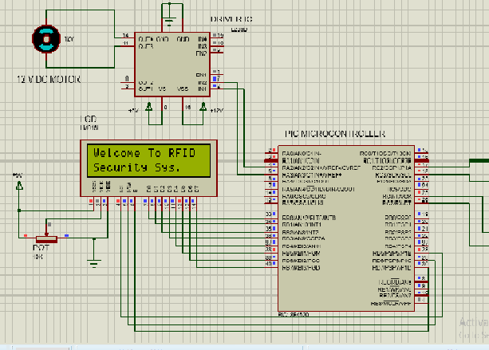

**Fig. no 7.2:** Simulation Result

**7.3 PCB LAYOUT**

Pad 2 Pad is a software tool used for electronic design automation. The software is used mainly to create PCB layout, it is easy to handle and place PCB footprints if any component not available in the library of pad2pad.

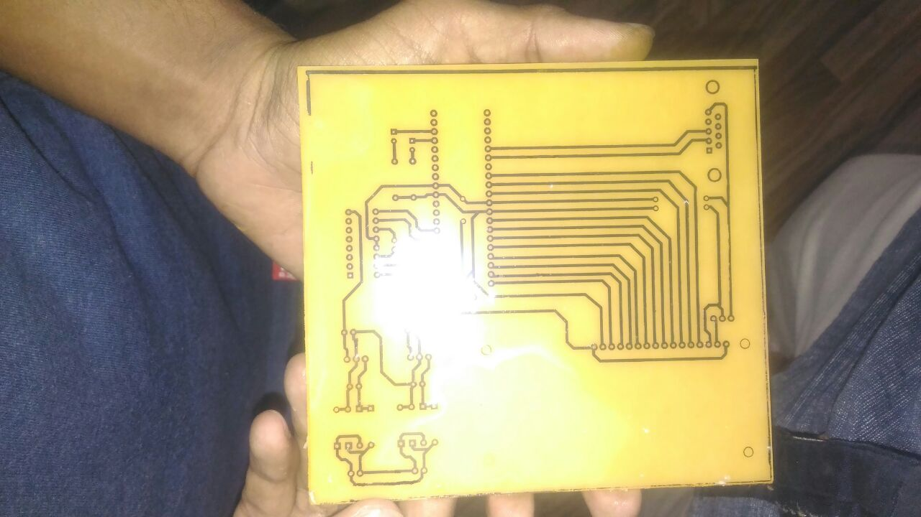

**Fig. no.** **7.3.1(a):** PCB layout

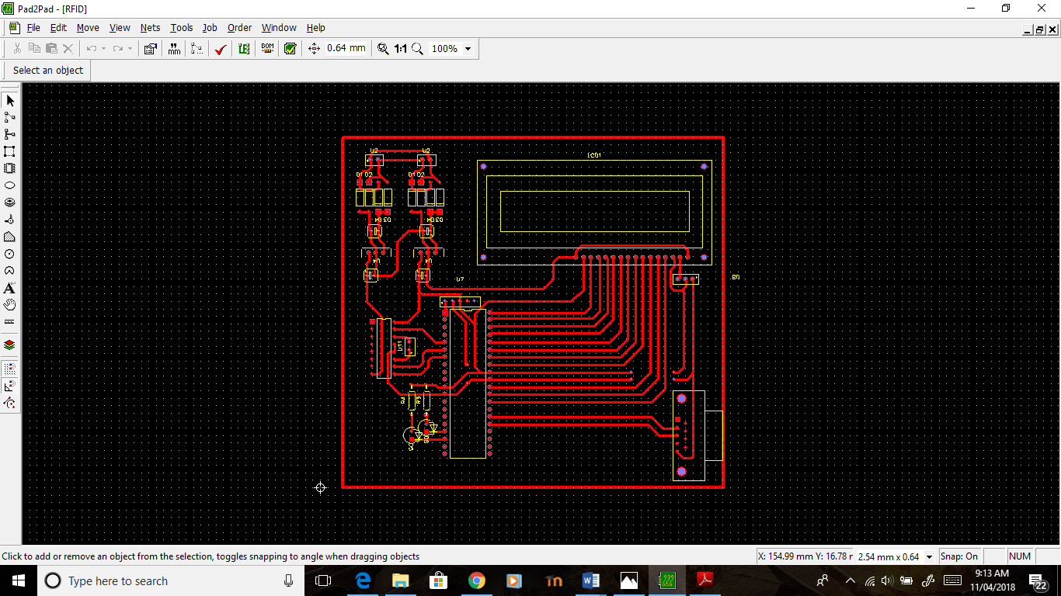

**Fig. no.7.3.1 (b):** layout on Pad2Pad

**5.4 ART WORK**

A number of methods are available for making PCBs. The simplest is drawing a pattern on an epoxy glass board with etch and resistant ink or paint, etching the board and drilling the holes. This method is suitable where no precision is required. Another method is to make silkscreen stencil by the photographic method. Print the pattern on the epoxy glass boards, etches, and drills the holes.

**5.4.1 MATERIALS**

Conducting layers are typically made of thin copper foil. Insulating layers’ dielectric are typically laminated together with epoxy resin pre prig. The board is typically coated with a solder mask that is green in color. Other colors that are normally available are blue and red. There are quite a few different dielectrics that can be chosen to provide different insulating values depending on the requirements of the circuit. Some of these dielectrics are polytetrafluoroethylene (Teflon), FR-4, FR-1, CEM-1 or CEM-3. Well known prepare materials used in the PCB industry are FR-2 (Phenol cotton paper), FR-3 (Cotton paper and epoxy), FR-4 (Woven glass and epoxy), FR-5 (Woven glass and epoxy), FR-6 (Matte glass and polyester), G-10(Woven glass and epoxy), CEM-1 (Cotton paper and epoxy), CEM-2 (Cotton paper and epoxy), CEM-3 (Woven glass and  epoxy),CEM-4 (Woven glass and epoxy), CEM-5 (Woven glass and polyester). Thermal expansion is an important consideration especially with BGA and naked die technologies, and glass fiber offers the best dimensional stability.

**5.4.2 PATTERNING**

The vast majority of printed circuit boards are made by bonding a layer of copper over the entire substrate, sometimes on both sides, (creating a "blank PCB") then removing unwanted copper after applying a temporary mask (e.g. by etching), leaving only the desired copper traces. A few PCBs are made by adding traces to the bare substrate (or a substrate with a very thin layer of copper) usually by a complex process of multiple electroplating steps. The PCB manufacturing method primarily depends on whether it is for production volume or sample/prototype quantities. PCB milling uses a two or three- axis mechanical milling system to mill away the copper foil from the substrate. A PCB milling machine (referred to as a 'PCB Prototype') operates in a similar way to a plotter, receiving commands from the host software that control the position of the milling head in the x, y, and (if relevant) z axis. Data to drive the Prototype is extracted from files generated in PCB design software and stored in HPGL or Gerber file format.

**5.4.3 ETCHING**

Chemical etching is done with ferric chloride, ammonium persulfate, or sometimes hydrochloric acid. For PTH (plated-through holes), additional steps of electro less deposition are done after the holes are drilled, then copper is electroplated to build up the thickness, the boards are screened, and plated with tin/lead. The tin/lead becomes the resist leaving the bare copper to be etched away.

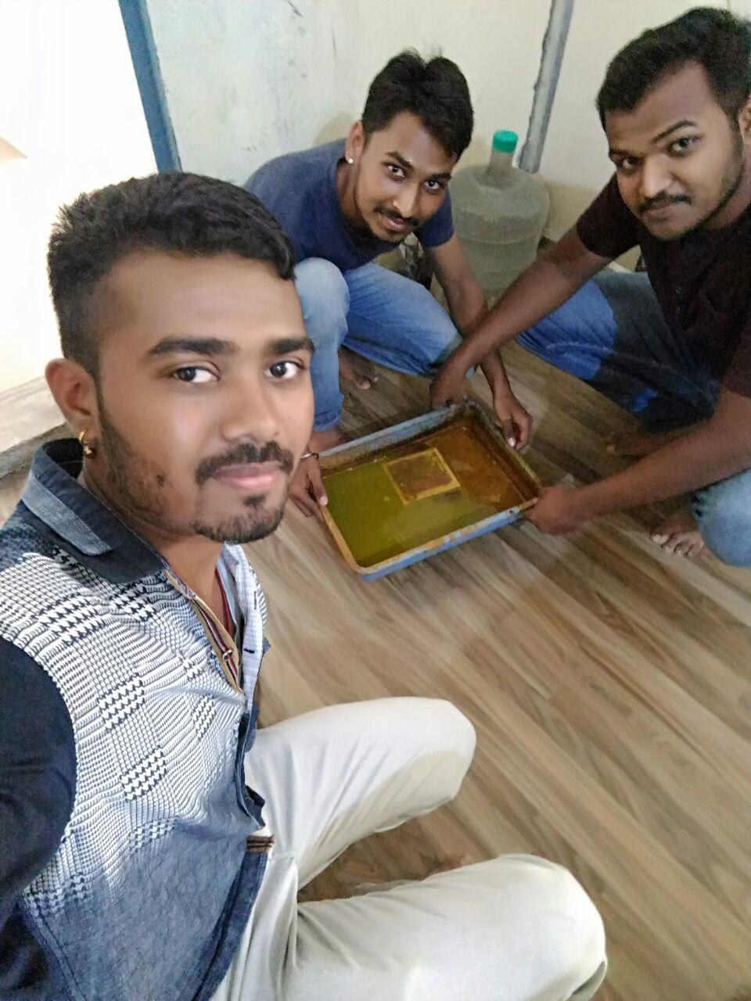

**Fig.no.5.4.3** Etching

**5.4.4 LAMINATION**

Some PCBs have trace layers inside the PCB and are called multi-layer PCBs. These are formed by bonding together separately etched thin boards.

**5.4.5 DRILLING**

Holes through a PCB are typically drilled with tiny drill bits made of solid tungsten carbide. The drilling is performed by automated drilling machines with placement controlled by a drill tape or drill file. These computer-generated files are also called numerically controlled drill (NCD) files or "Exelon files". The drill file describes the location and size of each drilled hole. These holes are often filled with annular rings (hollow rivets) to create vials. Vials allow the electrical and thermal connection of conductors on opposite sides of the PCB. Most common laminate is epoxy filled fiberglass. Drill bit wear is partly due to embedded glass, which is harder than steel. High drill speed necessary for cost effective drilling of hundreds of holes per board causes very high temperatures at the drill bit tip, and high temperatures (400-700 degrees) soften steel and decompose (oxidize) laminate filler. Copper is softer than epoxy and interior conductors may suffer.

**5.4.6 DAMAGE**

When very small vials are required, drilling with mechanical bits is costly because of high rates of wear and breakage. In this case, the vials may be evaporated by lasers. Laser-drilled vials typically have an inferior surface finish inside the hole. These holes are called micro vials. It is also possible with controlled-depth drilling, laser drilling, or by pre-drilling the individual sheets of the PCB before lamination, to produce holes that connect only some of the copper layers, rather than passing through the entire board. These holes are called blind vials when they connect an internal copper layer to an outer layer, or buried vials when they connect two or more internal copper layers and no outer layers. The walls of the holes, for boards with 2 or more layers, are made conductive then plated with copper to form plated-through holes that electrically connect the conducting layers of the PCB. For multilayer boards, those with 4 layers or more, drilling typically produces a smear of the high temperature decomposition products of bonding agent in the laminate system.

**5.4.7 EXPOSED CONDUCTOR PLATING and COATING**

PCBs are plated with solder, tin, or gold over nickel as a resist for etching away the unneeded underlying copper. After PCBs are etched and then rinsed with water, the solder mask is applied, and then any exposed copper is coated with solder, nickel/gold, or some other anti-corrosion coating. Traditionally, any exposed copper was coated with solder by Hot air solder leveling (HASL). This solder was a tin-lead alloy, however new solder compounds are now used to achieve compliance with the RoHS directive in the EU and US, which restricts the use of lead. One of these lead-free compounds is SN100CL, made up of 99.3% tin, 0.7% copper, 0.05% nickel, and a nominal of 60ppm germanium. It is important to use solder compatible with both the PCB and the parts used.

**5.4.8 SOLDER RESIST**

Areas that should not be soldered may be covered with a polymer solder resist (solder mask) coating. The solder resist prevents solder from bridging between conductors and creating short circuits. Solder resist also provides some protection from the environment. Solder resist is typically 20-30 micrometers` thick.

**5.4.9 COMPONENTS MOUNTING**

The leads of components like resistance and capacitor should be inserted carefully. An inserting the component carefully cut the lead of component so that the lead remains 3 mm above the soldering side of PCBs to make the field contact easily.

In case of semiconductor device such as transistor and diodes the length of leads extend above the component disc of PCB should remain about 5 mm. This prevents not only the heat, applied to each lead while soldering but also useful for measure voltage across these leads.

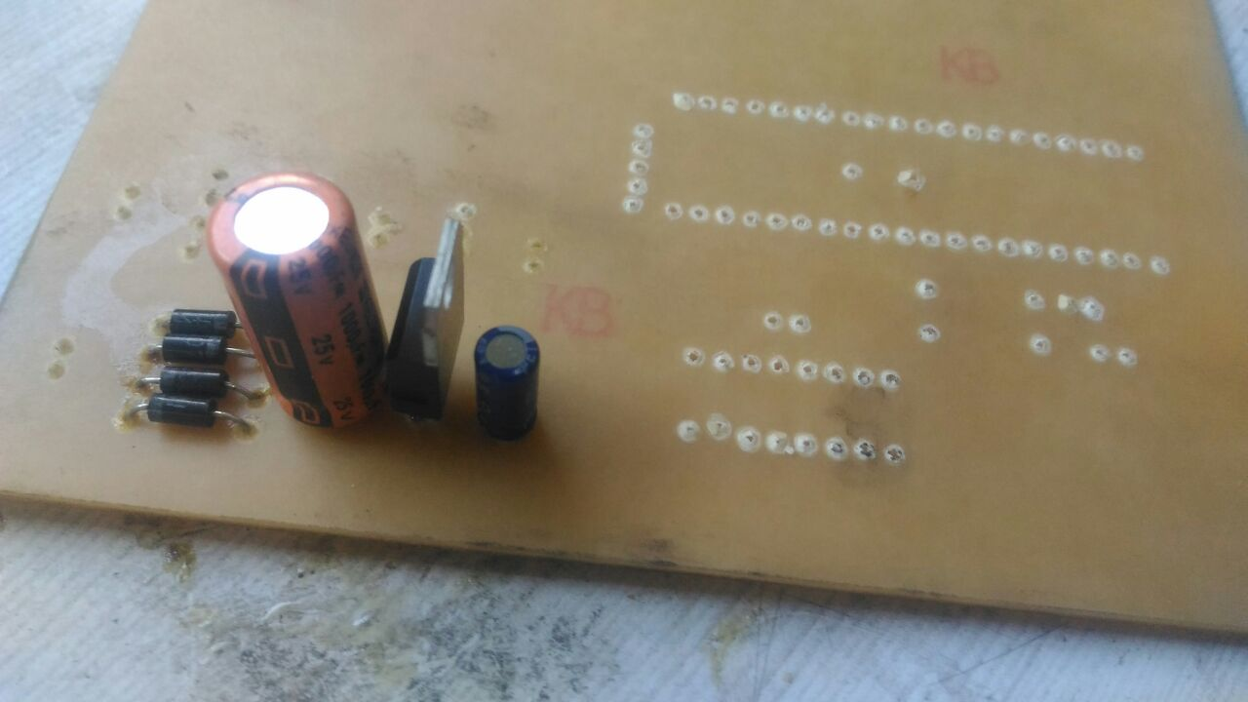

**Fig5.4.9** Components Mounting

**5.4.10 SOLDERING**

PCB soldering requires proper soldering techniques. For this one should have to use light duty soldering iron of the range 10 to 25 W. This prevents the damage of PCB due to excessive heating.

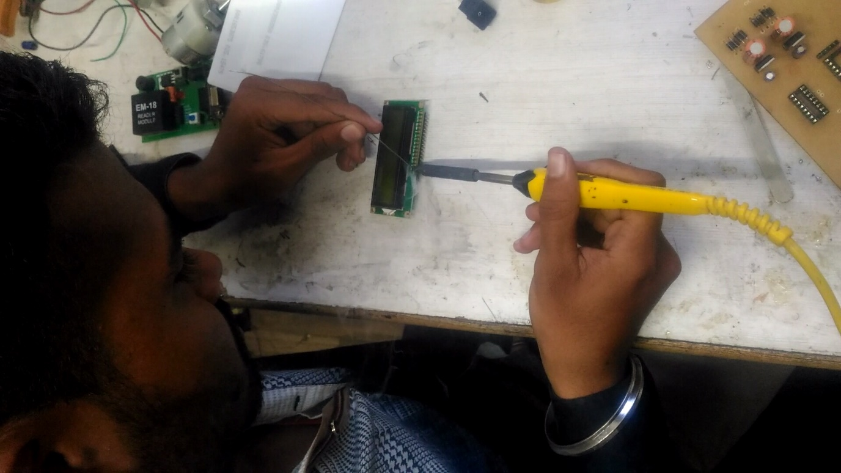

**Fig. 5.4.10** Soldering

**5.4.11 PRECAUTIONS**

While soldering the leads of components do not hold the soldering tip at the pins more than 10 sec. At a time, the pin should be allowed to cool to room temperature before applying hot soldering again to the same pin.

**CHAPTER 6**

**RESULTS AND CONCLUSIONS**

**RESULTS AND CONCLUSIONS**

* 1. **RESULTS**

1. When Authorized Card is detected according the “Authorized” message Display on the LCD screen.
2. Green LED blinks and PIC send output command to the L293D
3. After receiving command from the L293D driver IC DC motor starts rotating clockwise (as door opens) and some delay (100ms) motor starts rotating anticlockwise (as door closes).
4. When unauthorized card is detected accordingly the “Unauthorized” message display on the LCD screen and RED LED blinks for security indication.

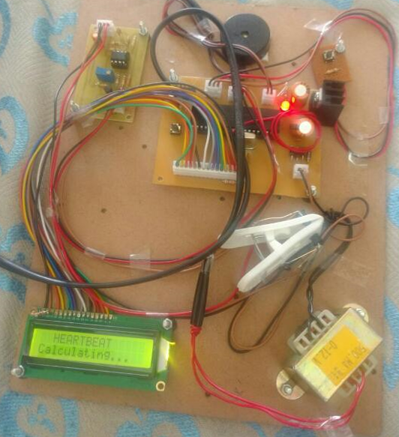

**Fig. No 6.1** Result

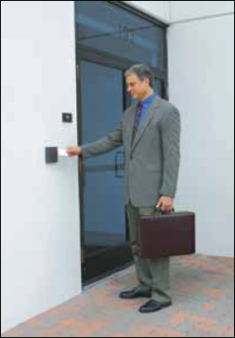

**6.2 ADVANTAGES**

1. This system control access of unauthorized person using RFID based smart card.
2. Provides tight security by automatically controlling the door system.
3. This project is fully automatic and does not require any manual operation.
4. Efficient and low cost design.
5. Low power consumption.
6. Easy to install the system.
7. Fast response.
   1. **LIMITATIONS**

1. Many RFID tag cannot work simultaneously it create signal collision.

2. x.

**6.4 CONCLUSIONS**

The above discussion shows that we have been able to implement and demonstrate a prototype of a RFID based security and secure the sensitive area with our module. RFID used which highly stable and reliable technology. RFID automatically detect the card is valid or not and do further process according to the validation of the tag.

**6.5 APPLICATIONS**

This system can be practically implemented in different places….

* Any Business organizations to avoid interference in data handling area.
* Warehouse or storage places where lot inventory movement is expected
* At hospitals, where high quality costly biomedical medicine, equipment is stored.
* We can use this project in our home as well.

**6.6 FUTURE SCOPE**

* Interfacing the system with a GSM so that data can be transmitted through messages.
* Implementing the security systems with different levels by using different types of the cards.
* We can add voice alert system to the RFID based security system for stronger system.
* **REFERENCES**

[1] Datasheet TRF7960-61 Multi-Standard Fully Integrated 13.56-MHz Radio

Frequency Identification (RFID) Analog Front End and Data Framing Reader

System, Texas Instruments.

[2] Identification cards - Contactless integrated circuit(s) cards. Part 3: Anti-collision

And transmission protocol, Texas Instruments, March 2000

[3] Datasheet PIC18F2420/2520/4420/4520, Microchip.

[4] website